CT-6113 "Long Claw"

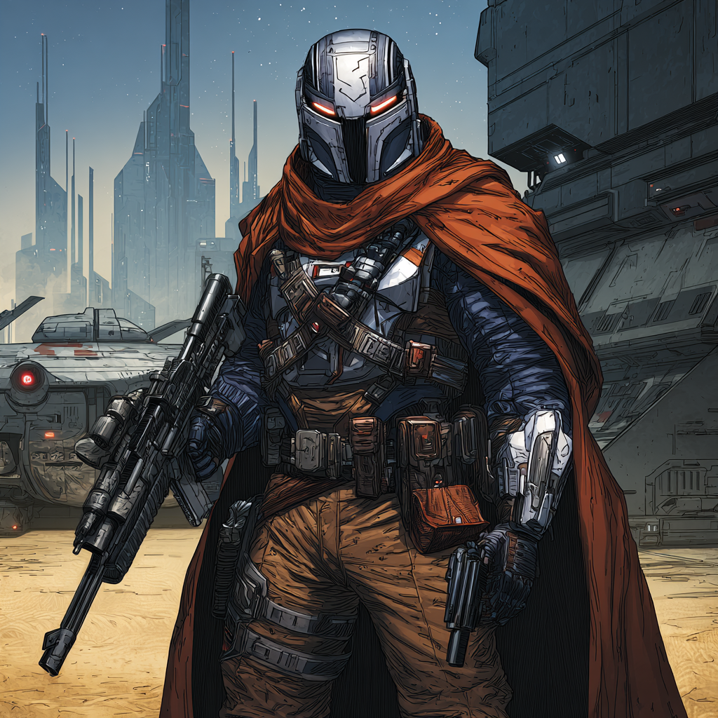
They called him Holt before he had a choice in the matter. Numbers first, always numbers with clones, but the nickname stuck during the siege of Cartao when he held the eastern gate for six hours. Civilians streamed past him while Separatist armor pushed forward. His squad wanted to fall back. Holt planted his feet and laid down covering fire until the last transport cleared the kill zone. The commander called it heroic. Holt called it the job.
He served with distinction through three years of war. Geonosis. Christophsis. The meat grinder campaigns nobody wrote songs about. He knew every man in his company by number and nickname both. He remembered who liked their rations heated and who could not sleep without checking their rifle twice.
When troopers died, he wrote their numbers in a field journal he kept inside his chest plate. Not their nicknames. Their numbers. The names the Republic gave them before they earned anything else.
The morning of Order 66 started like any other. Sunrise over a contested world. Check weapons. Review positions. Brief the squad. Then something shifted inside his skull. A noise that was not a noise. His hands moved to his rifle without his permission. His body turned toward the Jedi general who had saved his life on Felucia. Rage flooded his system. Not his rage. Something else's rage wearing his nervous system like armor.
His vision went red at the edges. The general's back was turned. Easy shot. His finger found the trigger. Then his training kicked in, the real training, the kind that kept soldiers alive when everything went wrong. This was wrong. His body was wrong. The order was wrong. He fought for control of his own hand and lost. The rifle came up.
"Medic," he managed to say through clenched teeth. The word came out strangled. The FX droid rolled over. Standard unit. White chassis. Designation F1X-3R painted on the shoulder. It had patched him up after dozen of firefights. The droid's optical sensors swept him once.
"Inhibitor chip malfunction detected," the droid said. No emotion. Just diagnosis. "Immediate intervention required."
The field surgery took eighteen minutes. No anesthetic. The droid explained that painkillers would interfere with neural mapping. Holt bit through a leather strap while the droid opened his skull. The smell of cauterized bone filled the medical tent. His squadmates continued executing the order outside. Blaster fire. Screaming. The sound of the Republic dying.
When the chip came out, the rage vanished. The compulsion disappeared. Holt's body became his own again. The droid sealed the wound and updated the medical log with a routine procedure code. Concussion treatment. Nothing worth investigating.
Holt walked out of the medical tent. The general was dead. His squad stood over the body with empty expressions. The war was over. The Republic was over. CT-6113 was over. He stripped his armor in a supply depot and walked away in civilian clothes. The droid followed.
"You require post-operative observation," F1X-3R said.
"I require a new name and a bottle of something strong."
"The second option would compromise your recovery."
They traveled together because neither had anywhere else to go. Holt took labor jobs. Loading freight. Mining asteroids. Security for merchants who could not afford better. The work never fit. His hands knew how to track targets through scope drift. His mind calculated firing solutions without thinking. He fell into bounty hunting because the galaxy did not offer many careers for men trained to hunt.
He picked the name Long Claw from an old Mandalorian he met in a cantina. The Mandalorian was dead, would not need it anymore. The name felt like armor he could take off at night. Better than numbers. Better than Holt.
The first bounties were simple. Bail jumpers. Petty thieves. Nobody worth mourning. He built rules to sleep at night. No children. No slaves. No trading lives for ledgers. The Empire wanted certain people found. Long Claw found some of them. The ones who deserved finding. The others got warnings and head starts.
F1X-3R never questioned the inconsistencies. The droid patched wounds and cooked meals and maintained equipment with mechanical precision. They developed a rhythm. Long Claw handled negotiations. The droid handled logistics. When fights turned lethal, they both handled the violence with professional efficiency.
Money was always tight. A surplus Firespray patrol craft sat in impound after its smuggler owner got caught running weapons to Separatist holdouts. The port authority wanted it gone. Too much paperwork to auction. Too expensive to maintain. Long Claw made an offer through intermediaries. The credits were barely enough.
The sale should have taken weeks. Background checks. Registration transfers. Imperial approval stamps. Instead, the paperwork vanished overnight. A new chain code appeared in the system. The ship was his. No questions. No traces.
The first message from Kestrel came through the Firespray's comm system three days later. Text only. No voice. No signature. "GAR residue scrubbed from your records. Port authority logs cleaned. Previous owner's debts erased. You fly free because I helped you fly free. I need pilots who know when to walk away. Jobs available if interested."
Long Claw was interested. Credits were credits. Kestrel's jobs came through dead drops. Encrypted coordinates. Target dossiers. Payment confirmations. Never a meeting. Never a voice. The bounties were always Imperial interests but never Imperial contracts. Corporate executives who skimmed Imperial funds. Pirates who hit the wrong supply lines. People the Empire wanted gone but could not officially target.
Long Claw took the jobs. The credits were good. Better than good. F1X-3R expressed no opinion about their employer. The droid rarely expressed opinions about anything beyond medical necessities and maintenance schedules.
Six months into the arrangement, an ISB net closed around Long Claw's previous crew. Three bounty hunters he had worked with before. Someone had traced old Republic records. Connected dots. The trap was set. Long Claw got word through a contact that ISB agents were waiting at the rendezvous.
He stayed away. His former partners walked into the ambush. Two died. One disappeared into an Imperial prison. Long Claw should have been there. Would have been there if the contact had not warned him. The contact died in a speeder accident the next day. Accidents happened.
Kestrel's message arrived that night: "ISB trap neutralized. Forged warrants uploaded to their system. Investigation redirected. Your name removed from relevant files. Debt incurred."
The debt came due three months later. A simple text: "Black-site courier requires interception. Coordinates attached. Bring the Firespray. Bring your medic. Others will meet you at the rendezvous. Complete the job and earn: abandoned clone armor cache location, clean transponder swap for your ship, and continued anonymity."
Long Claw looked at the coordinates. Outer Rim. Empty space. The kind of place where things happened that nobody reported. He looked at F1X-3R. The droid was cleaning its surgical tools. Always cleaning. Always maintaining.
"We have a job," Long Claw said.
"Medical supplies are fully stocked," the droid replied.
They flew toward the coordinates. The Firespray handled well despite its age. Long Claw had made modifications. Upgraded shields. Better sensors. A hidden compartment for weapons the Empire did not approve of civilians owning. F1X-3R had suggested several of the modifications. The droid understood survival as well as surgery.
The past followed them. It always did. Long Claw still carried his field journal with the numbers of dead brothers. He read them sometimes when space got too quiet. It reminded him that CT-6113 had existed. That Holt had existed. That before Long Claw, there was a soldier who believed in something.
Now he believed in simpler things. Keep flying. Keep F1X-3R functional. Keep the Empire's serial number databases from finding him. Take jobs that matter more than credits. Help when helping was possible. Survive when it was not.
The coordinates grew closer. Kestrel's debt would be paid. Then there would be other debts. Other jobs. Other reasons to keep flying. Long Claw was fine with that. The galaxy did not offer happy endings to clone deserters. It offered another day of freedom. That was enough.
He checked his weapons. He always checked them twice. Some habits survived even when the soldier did not.

